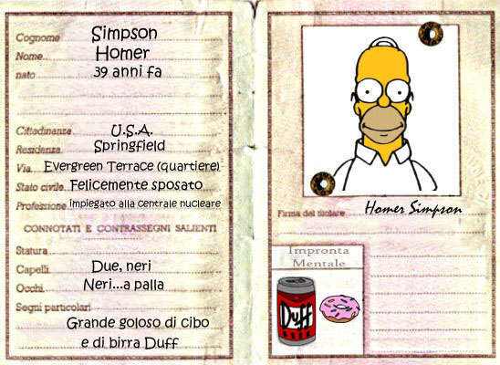

|  |  |
| --- | --- |
| Enrico Pezzano  Senza capelli si può aver successo ed essere felici. | Traversa alla costa 19/5  16153, Genova (GE)  **(+39) 3459 32 56 65**  **enrico.pezzano@outlook.it** |
| EXPERIENCEPiscine ‘Tea Benedetti’ Sestri Ponente, Via Borzoli 21 — *Lifeguard*JUNE 2018 - PRESENTE Currently part-time working at CNS swimming pool as lifeguard and as assistant. AMT, Via Bobbio 2— *Systems Analyst*JUNE 2018 - JUNE 2018 Worked at AMT public transport agency as a system analyst, in via Bobbio 2 (Genoa). NASA, Rome— *Astronaut & Secretary*FEBRUARY 2007 - SEPTEMBER 2010 I went to the moon and discovered a new way to cook pasta alla carbonara. EDUCATION & TRAININGITIS Italo Calvino, Genova — *Tecnico informatico*SETTEMBRE 2015 - GIUGNO 2019 5 years cycle of high school based in Italo Calvino, an secondary IT school. University , Genova— *Dibris*SETTEMBRE 2019 - XXXX 20XX Currently waiting the high school’s end to attend a more difficult IT course and finally get a degree. PROJECTSIndependent Home — *energy independence* Currently working on building an independent house powered by solar system’s panels and tiles, powerwall and powerbank. | SKILLS & COMPETENCE  * -Driving License (AM, B) * -Computer skills and competences. * -Social skills rapporting with people * -  LANGUAGES -Mother tongue: Italian  -Other languages: English (Level B2) |